PD Certificates for Teachers
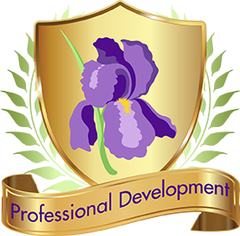
Flexible, user-friendly, and built around reliable and trustworthy resources, IRIS PD Certificates for Teachers allow individual users to pursue certificates for professional development hours. Through this feature, practitioners can work through a wide variety of our modules and—after completing a pre-test and post-test—receive verification of completion and an indication of the number of hours it typically takes users to complete that resource.
Getting started couldn’t be simpler: Create an account with a username and password. Next, browse available IRIS STAR Legacy Modules and select the ones that best suit your PD needs. Thirty-three modules are now available, and more are added all the time.
Once you have created an account and selected a module, you will:
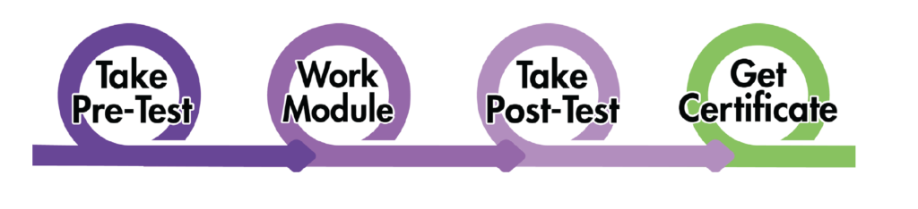
Your IRIS PD Certificate (email or PDF) includes your name, the module you completed, the date, the hours you earned, and your pre- and post-test scores, if you choose.
Want to share at-a-glance information about IRIS PD with your principal, superintendent, or other school administrator? We’ve done the work for you. Download and print this handy factsheet.

