Editorial

Why Other Countries Teach Better

Three Reasons Students Do Better Overseas
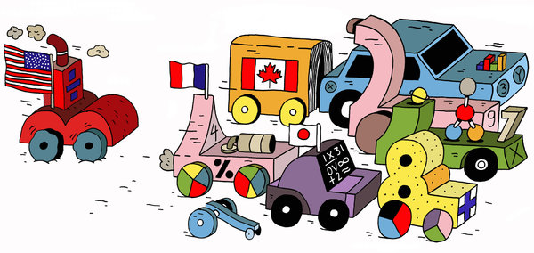

By THE EDITORIAL BOARD

Published: December 17, 2013

Millions of laid-off American factory workers were the first to realize that they were competing against job seekers around the globe with comparable skills but far smaller paychecks. But a similar fate also awaits workers who aspire to high-skilled, high-paying jobs in engineering and technical fields unless this country learns to prepare them to compete for the challenging work that the new global economy requires.
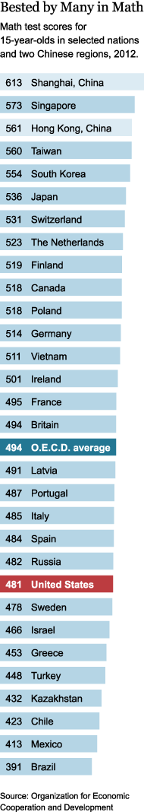

The New York Times
The American work force has some of the weakest mathematical and problem-solving skills in the developed world. In a recent survey by the Organization for Economic Cooperation and Development, a global policy organization, adults in the United States scored far below average and better than only two of 12 other developed comparison countries, Italy and Spain. Worse still, the United States is losing ground in worker training to countries in Europe and Asia whose schools are not just superior to ours but getting steadily better.
The lessons from those high-performing countries can no longer be ignored by the United States if it hopes to remain competitive.
Finland: Teacher Training
Though it dropped several rankings in last year’s tests, Finland has for years been in the highest global ranks in literacy and mathematical skills. The reason dates to the postwar period, when Finns first began to consider creating comprehensive schools that would provide a quality, high-level education for poor and wealthy alike. These schools stand out in several ways, providing daily hot meals; health and dental services; psychological counseling; and an array of services for families and children in need. None of the services are means tested. Moreover, all high school students must take one of the most rigorous required curriculums in the world, including physics, chemistry, biology, philosophy, music and at least two foreign languages.
But the most important effort has been in the training of teachers, where the country leads most of the world, including the United States, thanks to a national decision made in 1979. The country decided to move preparation out of teachers’ colleges and into the universities, where it became more rigorous. By professionalizing the teacher corps and raising its value in society, the Finns have made teaching the country’s most popular occupation for the young. These programs recruit from the top quarter of the graduating high school class, demonstrating that such training has a prestige lacking in the United States. In 2010, for example, 6,600 applicants competed for 660 available primary school preparation slots in the eight Finnish universities that educate teachers.
The teacher training system in this country is abysmal by comparison. A recent report by the National Council on Teacher Quality called teacher preparation programs “an industry of mediocrity,” rating only 10 percent of more than 1,200 of them as high quality. Most have low or no academic standards for entry. Admission requirements for teaching programs at the State University of New York were raised in September, but only a handful of other states have taken similar steps.
Finnish teachers are not drawn to the profession by money; they earn only slightly more than the national average salary. But their salaries go up by about a third in the first 15 years, several percentage points higher than those of their American counterparts. Finland also requires stronger academic credentials for its junior high and high school teachers and rewards them with higher salaries.
Canada: School funding
Canada also has a more rigorous and selective teacher preparation system than the United States, but the most striking difference between the countries is how they pay for their schools.
American school districts rely far too heavily on property taxes, which means districts in wealthy areas bring in more money than those in poor ones. State tax money to make up the gap usually falls far short of the need in districts where poverty and other challenges are greatest.
Americans tend to see such inequalities as the natural order of things. Canadians do not. In recent decades, for example, three of Canada’s largest and best-performing provinces — Alberta, British Columbia and Ontario — have each addressed the inequity issue by moving to province-level funding formulas. As a recent report by the Center for American Progress notes, these formulas allow the provinces to determine how much money each district will receive, based on each district’s size and needs. The systems even out the tax base and help ensure that resources are distributed equitably, not clustered in wealthy districts.
These were not boutique experiments. The Ontario system has more than two million public school students — more than in 45 American states and the District of Columbia. But the contrast to the American system could not be more clear. Ontario, for example, strives to eliminate or at least minimize the funding inequality that would otherwise exist between poor and wealthy districts. In most American states, however, the wealthiest, highest-spending districts spend about twice as much per pupil as the lowest-spending districts, according to a federal advisory commission report. In some states, including California, the ratio is more than three to one.
This has left 40 percent of American public school students in districts of “concentrated student poverty,” the commission’s report said.
Shanghai: Fighting Elitism
China’s educational system was largely destroyed during Mao Zedong’s “cultural revolution,” which devalued intellectual pursuits and demonized academics. Since shortly after Mao’s death in 1976, the country has been rebuilding its education system at lightning speed, led by Shanghai, the nation’s largest and most internationalized city. Shanghai, of course, has powerful tools at its disposal, including the might of the authoritarian state and the nation’s centuries-old reverence for scholarship and education. It has had little difficulty advancing a potent succession of reforms that allowed it to achieve universal enrollment rapidly. The real proof is that its students were first in the world in math, science and literacy on last year’s international exams.
One of its strengths is that the city has mainly moved away from an elitist system in which greater resources and elite instructors were given to favored schools, and toward a more egalitarian, neighborhood attendance system in which students of diverse backgrounds and abilities are educated under the same roof. The city has focused on bringing the once-shunned children of migrant workers into the school system. In the words of the O.E.C.D, Shanghai has embraced the notion that migrant children are also “our children” — meaning that city’s future depends in part on them and that they, too, should be included in the educational process. Shanghai has taken several approaches to repairing the disparity between strong schools and weak ones, as measured by infrastructure and educational quality. Some poor schools were closed, reorganized, or merged with higher-level schools. Money was transferred to poor, rural schools to construct new buildings or update old ones. Teachers were transferred from cities to rural areas and vice versa. Stronger urban schools were paired with rural schools with the aim of improving teaching methods. And under a more recent strategy, strong schools took over the administration of weak ones. The Chinese are betting that the ethos, management style and teaching used in the strong schools will be transferable.
America’s stature as an economic power is being threatened by societies above us and below us on the achievement scale. Wealthy nations with high-performing schools are consolidating their advantages and working hard to improve. At the same time, less-wealthy countries like Chile, Brazil, Indonesia and Peru, have made what the O.E.C.D. describes as “impressive gains catching up from very low levels of performance.” In other words, if things remain as they are, countries that lag behind us will one day overtake us.
The United States can either learn from its competitors abroad — and finally summon the will to make necessary policy changes — or fall further and further behind. The good news is that this country has an impressive history of school improvement, as reflected in the early-20th-century compulsory school movement and the postwar expansion, which broadened access to college. Similar levels of focus and effort will be needed to move forward again.

A version of this editorial appears in print on December 18, 2013, on page A28 of the New York edition with the headline: Why Other Countries Teach Better.

